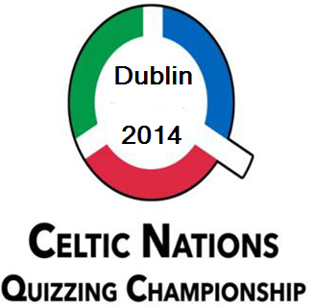

Instructions
- You have 75 minutes to complete this quiz
- Please write your answers in the appropriate box. Misplaced answers will be marked
incorrect.
- There are two parts to this quiz.
◦ Part 1 – 100 general questions. These will form your score for the benefit of the
placings.
◦ Part 2 – 15 tie breakers. These will only be used to determine placings in the event
of a tie. If scores can still not be separated, the 'nearest the pin' question will
decide positions.
- Unless instructed otherwise, when giving a person's name the surname alone will be
sufficient. An incorrect forename will cause an answer to be marked incorrect.
- This is not a test of spelling. If it is clear what you intend as your answer that is
sufficient. However, if you inadvertently write a plausible alternative answer, that must be accepted as your answer.
- Write your scores in the space below. Ensure that the marker of your paper also
signs to verify your score. Detach this slip and hand it in as instructed.

----------------------------------------------------------------------------------------------------------------

Celtic Nations Quizzing Championship 2013 – Individual Quiz

Competitor's Name:__________________________________________________

Country:____________________________________________________________

Marker's Name:______________________________________________________

PART 1 SCORE:_____________ PART 2 (TIE BREAK) SCORE:____________

Nearest the pin answer: __________________________

1 | Awarded the 1982 Nobel Prize in Literature, which Colombian novelist is best known for One Hundred Years of Solitude (1967) and Love in the Time of Cholera (1985)?
2 | Which 2013 film, starring Leonardo di Caprio, contains over  500 uses of the word ‘fuck’, setting a new record for a mainstream film?
3 | If a Boeing 747 is known as a “Jumbo Jet”, then which ten-letter epithet is given to a Boeing 787?
4 | Daddy Cool, Rivers of Babylon, and Mary’s Boy Child are among the best-known singles of which German pop group?
5 | Deriving from the Greek for ‘throw’, what ten-letter name is given to the science of mechanics that deals with the launching, flight, behaviour, and effects of projectiles such as rockets and bullets?
6 | The Spanish architect Santiago Calatrava is, perhaps, best-known as the creator of the Turning Torso, the tallest skyscraper in Scandinavia. It was erected in 2005 in which city that might be familiar to fans of the TV series Broen (‘The Bridge’)?  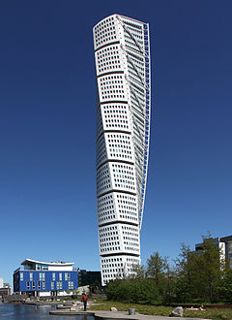
7 | John le Carré’s 1968 spy novel A Small Town in Germany alludes to which city, that has become rather less significant since 1990?
8 | Now known as part of the name of a sporting competition, what Spanish word refers to those men, like Simon Bolivar, Miguel Hidalgo y Costilla, Bernardo O'Higgins, José de San Martín, and Francisco de Miranda, who served as the principal leaders of the Latin American wars of independence from Spain and Portugal?
9 | Also appearing in the God of War video game series,  which Greek monster fathered the Nemean Lion , Cerberus, the Hydra, and the Chimera and temporarily managed to chase all the Gods from Mount Olympus?
10 | Which musician represented Thailand as an alpine skier at the 2014 Sochi Winter Olympics under the name of Vanessa Vanakorn?
11 | US professional assassin and CIA operative Michael Townley was involved in the assassination of the diplomat Orlando Letelier (in Washington in 1976) and General Carlos Prats (in Buenos Aires in 1974). Both assassinations were ordered by the DINA, the now-defunct secret police of which South American country?
12 | Paleozoologists have been able to piece together a more complete picture of the evolutionary lineage of this animal than that of any other mammal. Its ancestors including the eohippus and the mesohippus, which animal is this?
13 | He will celebrate his 90th birthday later this year. Which man is the oldest living former U.S. President?
14 | In February 2014, a novella written by Charlie Chaplin was published for the first time. It had formed the basis of which 1952 film in which a fading comedian helps a despondent ballet dancer learn to feel confident about life again?
15 | Also the home of the famous Fugger banking family, which German city gives its name to the primary confession of faith of the Lutheran Church that was presented to the Holy Roman Emperor Charles V in June 1530?
16 | Once a French colony and part of the ancient land of Punt, which nation is home to Camp Lemonnier, the USA's primary military base on the continent of Africa?
17 | Which name is shared by the oldest daughter of Barack Obama (b. 1998) and a touristic town on Crete famous for its nightlife?
18 | Formerly court stables, they were renovated between 1998 and 2001, when they were reopened as unique complex of museums, galleries, artistic pavilions, restaurants, and bars. MUMOK and the Leopold Museum are two of the most important art galleries in the museum quarter of which European capital city?
19 | Although it was one of the five original members of the U.N. Security Council, which founding member of the United Nations was expelled in 1971 and has not been readmitted?
20 | In which zodiacal constellation might the Crab Nebula be found? Strange as it might seem, the answer is not ‘Cancer’!
21 | One of the best known of the autism spectrum disorders, which neurological disorder - characterized by difficulties in social interaction and restricted patterns of behaviour and interests - is named after the Austrian paediatrician who first described it in 1944?
22 | The 2014 Winter Olympics in Sochi were held under the slogan "Hot. Cool. Yours", referencing the fact that the city is temperate enough to be the site of coastal palm trees. It is not, however, the most southerly city to host the Winter Olympics. Which city is?
23 | A jazz festival, combining music and leisure activities, is held every May in the Belgian village of Liberchies to celebrate its most famous son. After whom is the festival named?
24 | The 2013 United States Formula One Grand Prix was held in which city, the capital of its state? The 2014 event will, again, be held here.
25 | Hugely popular with tourists to Barcelona, which 1.2 km-long tree-lined mall connects the Plaça Catalunya in the centre of the city with the Christopher Columbus monument at Port Vell?
26 | Which French quantum physicist, later the inheritor of a Dukedom, postulated the wave properties of electrons in his PhD thesis, relating wavelength to momentum?
27 | What is the name of this school friend of Charlie Brown in the Peanuts comic strip (surname not required)?
28 | The New Zealander Jane Campion is the only female director to have won the Palme d’Or. She won the award for which 1993 film?
29 | Los Caprichos was a series of 80 aquatints – produced between 1797 and 1798 – that condemned the universal follies and foolishness of the Spanish society in which the artist lived. Who created this series?
30 | Chad Smith is well-known for his strong resemblance to the  actor Will Ferrell which has led to him wearing ‘I Am Not Will  Ferrell’ tee-shirts on stage. He is the drummer with which  American rock band known for hits such as Under the Bridge,  By the Way, and Dani California?  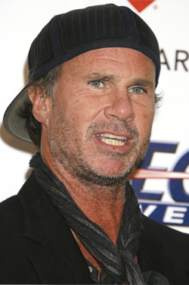
31 | Existing for over a thousand years, the Way of St. James is a major Christian pilgrimage route to which Spanish city, where tradition has it that the remains of St. James are buried?
32 | Alpha particles are identical in all respects - save their energy - to the nuclei of which element?
33 | The airport code KEF – the first three letters of the city in which it is to be found - designates the largest airport in which European country?
34 | Located in the present-day Mexican state of Tobasco, La Venta is a pre-Columbian archaeological site particularly noted for its four colossal basalt heads. They were fashioned by which Mesoamerican civilisation?  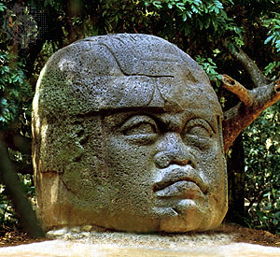
35 | As in football, rugby, and several other sports, field hockey has yellow and red cards that may be shown to players who have committed an offence. However, field hockey has a third card of which colour that indicates an official warning when a minor offence, not warranting a yellow card, has occurred?
36 | Two British fashion designers give their names to brands now owned by the Gucci fashion house stable. Alexander McQueen is one, but which famous name is the other?
37 | Meaning ‘black land’ in Sindarin, what was the name of the dwelling place of Sauron, in Tolkien’s Middle Earth, and home to the volcano Orodruin?
38 | Unveiled in 1969, Astron was the world's first quartz wristwatch. It was manufactured by which Japanese company whose name translates roughly as ‘House of Exquisite Workmanship’?
39 | Which French region gives its name to one of the most popular variants of quiche, made with bacon and cheese (when onions are added, it becomes known as a Quiche Alsacienne)?
40 | Introduced in the 1950s, PET is an imaging technique used in  nuclear medicine which produces a three-dimensional image of functional processes in the body. If the ‘P’ stands for ‘positron’ and the ‘E’ stands for ‘emission’, then what does the ‘T’ stand for?
41 | For the centenary of Henrik Ibsen’s death in 2006, this play held the distinction of being the world's most commonly performed dramatic work. Which play, shocking and controversial at the time, sees the protagonist, Nora Helmer, leave her husband and children because she wants to discover herself?
42 | This iconic and oft parodied film scene, showing the shadow of the vampire Count Orlok creeping up a staircase, is taken from which 1922 German Expressionist horror film directed by F. W. Murnau?  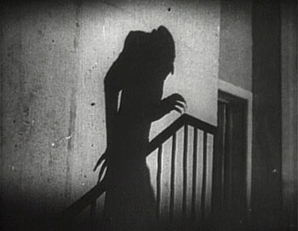
43 | The Prince Philip Movement is a religious sect that venerates the Duke of Edinburgh, believing him to be the pale-skinned son of a mountain spirit. The religion is practised on the island of Tanna in which Pacific island nation?
44 | Which American TV drama series includes, among its many conflicts, one between the Stark and Lannister families?
45 | An unorthodox production by Hans Neuenfels in Berlin in 2006 showed the eponymous Cretan king staggering on stage carrying a bag of the severed heads of Neptune, Jesus, Buddha, and the prophet Muhammad. This caused great controversy and the opera house was warned by authorities that it might provoke terrorism. Which Mozart opera depicts the daughter of Trojan King Priam and her love affair with the son of the Cretan enemy?
46 | Traditionally made from a mixture of goat and sheep milk, halloumi is a cheese with worldwide popularity that originated in which island nation?
47 | With a flat body and usually heavily inlaid with mother-of-pearl, what is the name of this long-necked lute that is the mainstay of modern Greek music?  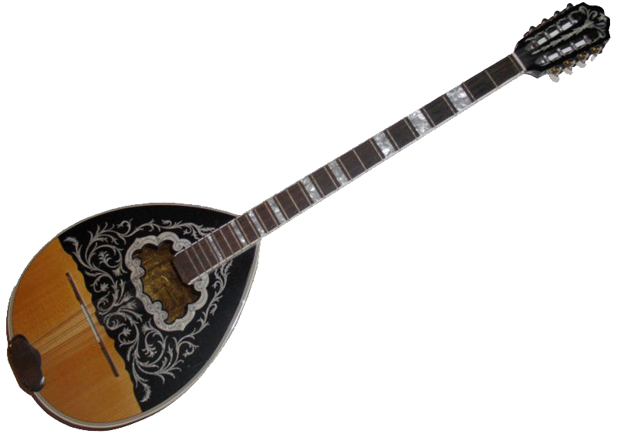
48 | Although born in Azerbaijan in 1973, the billionaire investor Isobel dos Santos is Africa’s richest woman. She is the daughter of a former president of which African nation?
49 | Stung by criticism that his creation was plagiarised, addictive, and devilishly difficult to use, Dong Nguyen may have pulled his app from Apple's App Store but it hasn't stopped clones from proliferating, including a dozen that have recently featured in the top 100 best-sellers in the Apple iTunes App Store. What was the name of Dong Nguyen's creation?
50 | The start of the Isle of Man TT race takes place each year in which month?
51 | Mentioned more often than she is in the New Testament, who is, perhaps a little surprisingly, the only woman mentioned by name in the Koran?
52 | The Battle of San Juan Hill (1898) was the decisive battle of the Spanish-American War and was fought on which island nation?
53 | Sometimes called Canada's informal 'national food', and pronounced locally like the name of a controversial world leader, it consists of French fries smothered with a light brown gravy-like sauce and cheese curds. What is this dish called?
54 | Although it is Germany’s second-longest river, the Elbe rises in the Krkonoše Mountains in which other E.U. country?
55 | Which familiar SI unit can legitimately be expressed as a joule per coulomb?
56 | Launched in 2012, the Friends product range (including "mini-doll" figures) replaced the previous female-oriented range, Belville, which had been in production since 1994. Critics claim the product line increases gender stereotypes even though Friends is one of the biggest sellers for which toy manufacturer known to stimulate building skills?
57 | Which small ray-finned fish of the Echeneidae family displays a well-known form of commensalism by attaching itself to sharks, manta rays, whales, turtles, and dugongs for easy transportation?
58 | He was a devout Catholic, who kept on his piano a music-rack in which was carved an image of the face of Jesus. Which 19th century French composer’s Pontifical Anthem (Marche Pontificale, 1869) became the official national anthem of Vatican City in 1949?
59 | This is the original study made by Vincent van Gogh before painting which 1885 work?  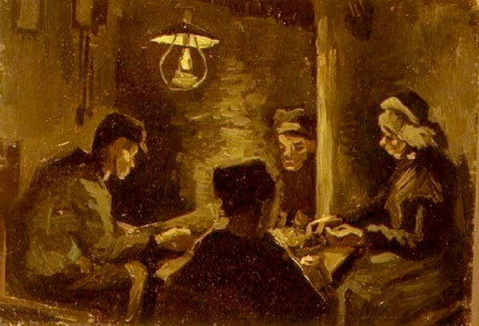
60 | This Roman general and politician rose to political prominence following his victory over the slave revolt led by Spartacus. A member of the First Triumvirate with Julius Caesar and Pompey the Great, he is considered one of the wealthiest men in history. Which general was killed at the battle of Carrhae, one of the most crushing defeats in Roman history?
61 | Literally meaning ‘gift’ in Chinook, which word is applied to the lavish gift-giving festivals practised by aboriginal peoples of the North American Pacific coast?
62 | Better Call Saul stars Bob Odenkirk as Saul Goodman, a criminal lawyer who can easily be found in the Yellow Pages of Albuquerque. Better Call Saul is a prequel of which acclaimed TV series?
63 | The Social Democrat Friedrich Ebert was Germany's first President – serving until 1925. His son later served, certainly not quite to the old man's liking, as mayor of which major city (two words required)?
64 | Nicknamed Aslan (meaning ‘The Lion’) and Sarı Kırmızılılar (meaning ‘Yellow-Reds’), which football team is now managed by former Manchester City boss Roberto Mancini?
65 | Its name is derived from the Greek for ‘goat’ and it is popularly pierced in North American and European culture. What name is given to the small pointed eminence of the external ear, situated in front of the concha, which projects backward over the meatus?  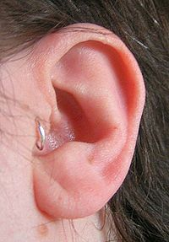
66 | Which municipality in the Belgian province of Antwerp has given its name to a heavy woollen cloth used to make overcoats and various kinds of luggage?
67 | The ozone layer lies within which of the Earth’s major atmospheric layers?
68 | Now an accountant in Germany, Abdul Ahad Momand became, in 1988, the first and only man of which country to travel to outer space? He was the first person to speak Pashto in space, and the first Muslim to recite the Koran in space.
69 | The fourth largest of New York’s five boroughs both in terms of population and area, which is the only borough to be located primarily on the mainland?
70 | What name is shared by the Roman Emperor who was murdered on the orders of the Persian King Shapur I after being taken captive following the Battle of Edessa in 260 AD and a perennial flowering plant - with heads of sweetly scented pink or white flowers - used as a perfume in the sixteenth century?  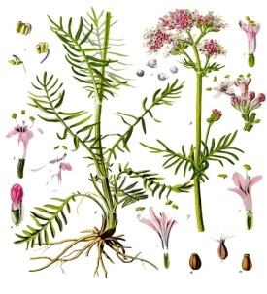
71 | The little Finnish town of Sonkajärvi is home to an interesting World Championships held every year since 1997. What unusual load is carried by the male competitors in this 235 meter-long race?
72 | Nowadays, the Marangu Route is the most popular track used to climb which famous mountain, the highest on its continent?
73 | In mathematics, which concept is symbolically represented as a lemniscate ()?
74 | Subtitled A Novel About Three Army Doctors, which 1968 novel – later adapted to both film and television - was written by "Richard Hooker" (a joint pen name used by the military surgeon Dr. H. Richard Hornberger and the sportswriter W. C. Heinz)?
75 | Originating in 17th century Japan, what name is given to a miniature ornamental sculpture that is used as a fixture on a man's sash, from which small personal belongings are hung?
76 | The Silent World (1956) and World Without Sun (1964) both won the Academy Award for Best Documentary Feature. Both were directed by which Frenchman?
77 | Leonardo da Vinci’s Mona Lisa is painted in oil on a panel made from which wood?
78 | Its name is taken from the colour of the laser used to read and write to it and it can store almost six times more data than a traditional DVD. Which optical disc storage medium was designed by Sony to supersede the standard DVD format?
79 | Found throughout temperate Asia and Europe (and familiar in both British and Irish gardens), which bird, Prunella modularis, is the most widespread member of the accentor family?  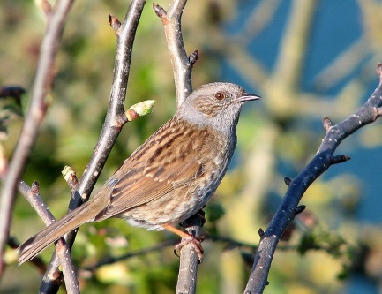
80 | The Romans were the first to attain high standards for its production and use, and the dome of the Pantheon in Rome is the world’s largest structure made of this material. Which composite substance is the world’s most widely used man-made material?
81 | Which Armenian is currently ranked as the number 2 chess player in the world, and is widely regarded as the favourite to be the next challenger to the World Championship title of Magnus Carlsen?
82 | Famed for its marzipan, which German port was the most powerful member of, and effectively the ‘capital’ of, the Hanseatic League?
83 | Along with Spanish, Guaraní is one of the two official languages of which South American country where it is spoken by the majority of the population?
84 | What worldwide pop hit from the current decade was inspired by a 1976 National Geographic magazine photographic of baseball player George Brett wearing his uniform and signing autographs for his adoring fans?
85 | When Sweden's Jonas von Essen was on Newsnight in December 2013, he had considerable trouble trying to recall Jeremy Paxman's name. Shortly beforehand, he had won which title in London to follow in the footsteps of Ben Pridmore, Clemens Mayer, and Wang Feng?
86 | Its prevalence among people from tropical and sub-tropical regions is thought to be a result of its increased resistance to malaria. The mutated haemoglobin gene that causes which blood disorder, characterized by rigid, abnormally shaped red blood cells, is carried by one-third of all aboriginal inhabitants of Sub-Saharan Africa?
87 | Which now-deceased tennis player – the winner of one of the two Australian Open tournaments in 1977 – said, when finally beating Jimmy Connors after 16 straight losses in 1980: "And let that be a lesson to you all. Nobody beats ______ ______ 17 times in a row!"?
88 | Bearing the name of the district where it is located, which famous fountain in Rome - designed by Italian architect Nicola Salvi and completed by Pietro Bracci – is the largest Baroque fountain in the city?  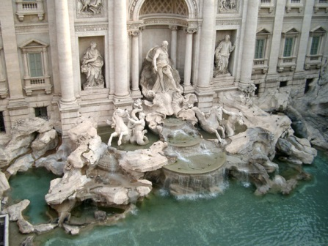
89 | A feature of severe weather and atmospheric instability by producing lightning, hail, and tornados, which type of dense and vertical cloud takes its name for the Latin for ‘heap of storm-rain’?
90 | Subtitled Prelude to a Philosophy of the Future, in which 1886 book did Friedrich Nietzsche attack the blind acceptance of Christian axioms in the consideration of morality?
91 | Known for directing two Harry Potter movies, Mrs Doubtfire, and The Help, which American film director gave his production company the appropriate name 1492 Pictures when he founded it in 1995?
92 | Matteo Renzi - the current Italian Prime Minister - is the youngest person ever to hold that post since unification in 1861, and the first to lead a government serving as a mayor rather than as a member of parliament. Until March 2014, he was the mayor of which Italian city?
93 | Depending on whom you believe, his introduction either came about as a result of an article in Pravda or in response to the popularity of Davy Jones (of The Monkees). What is the name of this fictional character from the Star Trek universe, originally portrayed by Walter Koenig?  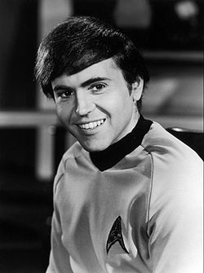
94 | The child of Russian-Jewish immigrants, Emmanuel Radnitzky was a significant contributor to both the Dada and Surrealist movements. Best known for his avant-garde photography, by what name is he better remembered?
95 | His opera La bohème was written contemporaneously with Giacomo Puccini's own treatment of the same story and whilst Puccini's opera has become a standard in the operatic repertoire, this man’s version is rarely performed. However, he is well known today for his opera Pagliacci which recounts the tragedy of a jealous husband in a commedia dell'arte troupe. Who is this composer?
96 | Which man – who may or may not have loved lasagne - was shot as he was about to board a train in Washington, D.C. on July 2, 1881? He was severely wounded and died 80 days later.
97 | When Jimmy Fallon received one of these prizes he quipped, "Thank God Conan got promoted". Which internet award is famous for the restriction of winners' speeches to five words?
98 | Which Welsh village, built between 1925 and 1975, owes its Mediterranean flavour to its architect’s love of the Italian village of Portofino?
99 | Which Scottish city – effectively the capital of Scotland in the 12th and 13th centuries – is home to Scone Abbey from whence the Stone of Scone was stolen by Edward I?
100 | Which Irish county gives its name to a popular form of tweed made from wool taken from bog-dwelling sheep, and dyed with indigenous plants such as blackberries, fuchsia, gorse, and moss?
 | TIEBREAKERS
1 | The epicentre of the 2014 anti-Government protests in Ukraine, 'Independence Square' in central Kiev is better-known by a name that means 'square' in Ukrainian. This is which six-letter word whose cognates in languages like Arabic, Urdu, Persian, and Turkish sound and mean the same?
2 | He was selected as second pick in the 1988 NBA draft, and spent his entire career with the Indiana Pacers, where he was once named an NBA All-star. Who is widely considered the best Dutch basketball player of all time?
3 | A shy, psychic creature, this is which Pokémon character whose name is shared with both a sound made by a familiar animal and with a Danish alternative rock band?  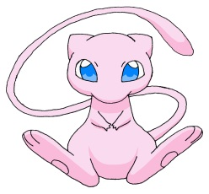
4 | President Yoweri Museveni told thousands of supporters that his country could live without economical aid from Western donors. The aids were suspended or diverted in protest at an anti-gay bill that became law in February in which African country?
5 | What relation was King Louis XIV (the fourteenth) of France to King Louis XVI (the sixteenth)?
6 | According to Nordic mythology, what is the job of the four dwarves Norðri, Suðri, Austri and Vestri?
7 | The most famous exhibit of the Egyptian Museum in Cairo bears the inventory number "JE 60672". Made of gold, what is it?
8 | Elvis Costello’s 2013 album Wise Up Ghost is a collaboration with which versatile hip-hop and soul group from Philadelphia?
9 | The American sports clothing company Under Armour produced the scientifically designed bodysuits that were blamed for the U.S. team’s poor performance in which sport at the Sochi Winter Olympics?
10 | First recorded in 1801 by the explorer Alexander von Humboldt, Ceroxylon quindiuense is the national tree of Colombia and – at 60 metres - the tallest monocot tree in the world. It is an example of which family of trees?
11 | In 2010, remains of a species of Homo – or possibly a subspecies of Homo sapiens - were found on the Russian-Kazakh border. What name was given to these hominids resembling both Neanderthals and modern humans?
12 | What is the four letter pseudonym of the American internet entrepreneur Christopher Poole who founded the hugely influential 4chan website?
13 | Claude Monet's Impression, Sunrise (1872), which gave the Impressionist movement its name, was an image of which French harbour port in Haute-Normandie?
14 | He's not a prodigy at all but a feeble, lonely middle aged man. Nevertheless Chris Ware calls him "the smartest kid on earth" in the subtitle of his acclaimed graphic novel. Who?
15 | Hideki Yukawa, the first Japanese Nobel laureate, won the Nobel Prize in Physics in 1949 for his prediction of the existence of which subatomic particles that appear in nature only as short-lived products of cosmic ray interaction with matter, and which explain the interaction between protons and neutrons?

Nearest the pin tiebreaker:
In which year did the rural communes of Uri, Schwyz, and Unterwalden agree a federal charter, thus creating the precursor to the modern state of Switzerland?

_________________________________

Thank you for your participation.

Questions written by:
Rob Hannah (Scotland)
David Edwards (Wales)
Didier Bruyère (France)
Holger Waldenberger (Germany)
Sebastian Jacoby (Germany)
Movin Miranda (India)
Thomas Kolåsæter (Norway)
Tore Dahl (Norway)
Bojan Lukic (Serbia)
Ed Toutant (USA)

Quiz edited by:
Rob Hannah (Scotland)

